Analysis of a Clinical Trial for Essential Tremor
Why Praxis Precision Pharmaceuticals could succeed in its Phase 3 Clinical Trial

By Snaking
Jan 2025

Executive Summary
Praxis Pharmaceuticals’ ESSENTIAL3 Phase III trial WILL FAIL.
Readout is expected to be in Q1 2025.
In a Phase 2b clinical trial (ESSENTIAL1) data proved conflicting, with both benefits and impairments in items supposed to be strongly correlated.
The drug’s supposed Mechanism of Action has been tested before without any success whatsoever. Thrice.
$PRAX is not a one-drug company, which limits price action in case of failure. The company has a cash value of $19,31 per share according to the last quarterly report’s Balance Sheet and other phase 2 and 3 clinical trials on the way.
In case of failure, I expect a stock price decrease of at least 50% (from the current price of 79$).
It is important to remind the reader that the criteria used to evaluate efficacy in this Phase 3 clinical trial is entirely patient/therapist reported. Thus, limited linearity between Phase 3 results and drug efficacy are to be considered.

Introduction
Praxis Pharmaceuticals is a Clinical-stage biopharmaceutical company focused on the development of therapies for central nervous system disorders characterized by neuronal imbalance. Its lead product candidate is PRAX-994, also known as ulixacaltamide (a selective small molecule inhibitor of T-type calcium channels, for the treatment of Essential Tremor, in Phase III of its clinical trial process).
In this document, I’ll be focusing on PRAX-994 and its Phase IIb and III.
Having a clear understanding of the following scales is vital to the discussion:
- ADL (Activities of Daily Living): Generally, refers to tasks and activities individuals do in their daily lives such as eating, dressing and personal hygiene. It is a concept used in many scales to assess a person's functional ability
- TETRAS (The Essential Tremor Rating Assessment Scale): was developed by the Tremor Research Group to quantify essential tremor severity and its impact on activities of daily living. TETRAS has an activities of daily living (ADL) section and a performance section.
- TETRAS-ADL (The Essential Tremor Rating Assessment Scale – Activities of Daily Living): assesses how tremor impacts daily activities
- TETRAS-PS (The Essential Tremor Rating Assessment Scale – Performance Scale): evaluates tremor during specific tasks
- mADL (Modified Activities of Daily Living): a modified measure of TETRAS-ADL which excludes item 12 – Social Impact (TETRAS-ADL includes 12 items); and adds 2 TETRAS-PS items (PS6 – Spirals; PS7 - Handwritting)
- mADL11 (Modified Activities of Daily Living Items 1 through 11): mADL except for TETRAS-PS items (6 & 7).

The above scales are strongly correlated.

What leads to uncertainty of Phase III success?
Phase 2b results showed effectiveness in mADL1-11 items (mADL excluding PS6 and PS7), while presenting impairments in TETRAS-PS items 6 and 7.
This alone is enough to have significant doubts about the efficacy of ulixacaltamide (PRAX-994) for the following reasons:
Modified Activities of Daily Living 1 through 11, mADL1-11 (the items in blue), is a scale that measures ability of engaging in routine tasks, such as “Dressing”, “Writing”, “Using Keys”, … This scale is entirely reported by the patient/therapist, adding a layer of subjectivity to the readability of the scale.
The Essential Tremor Rating Assessment Scale - Performance Scale, TETRAS-PS (the items in pink), is designed to quantify essential tremor severity based on estimates of peak-to-peak tremor amplitude, not on subjective anchors such as “normal, mild, moderate and severe”, which are biased by the variable clinical experience of examiners.
It is very clear that if ulixacaltamide offered any true benefits in Essential Tremor, a well-powered study would not show contradictions between the two scales. If anything, we should rely on the less subjective TETRAS-PS items 6 and 7 (Spirals and Handwriting) more than the subjective ones.
The company decided to proceed with a Phase 3 trial with primary endpoint mADL11, after making the post-hoc observation that removing TETRAS-PS items 6 and 7 would lead to a significant nominal p value, with no corrections applied.
This logic is flawed. The kind of post-hoc analysis that was used here is well-known in the scientific community as one of the most common mistakes a clinical trial can make: Drawing conclusions around hypothesis not created a priori.
In analyzing any set of data, there will seem to be “connections” or “results” in certain subsets just by random chance.
The idea that ulixacaltamide could benefit patient life quality (as measured by ADL) while impairing the disease’s state (as measured by PS) is absurd. Thus, I suggest 2 possible explanations:
- Ulixacaltamide’s negative PS effect was purely due to chance, and Phase 3 will show effects
- Ulixacaltamide’s positive ADL effect was purely due to chance, and Phase 3 will NOT show effects
I will entertain the second hypothesis for the rest of this work.
Praxis Pharmaceuticals’ Proposed Justification for the Inconsistency between ADL and PS results

Praxis Pharmaceuticals’ explanation as for why there was no concordance between Activities of Daily Living and Performance Scale items, as well as for why the trial failed in general was the incidence of Intention Tremor in Essential Tremor.
Intention tremor is a type of tremor characterized by rhythmic and high amplitude oscillations during directed and purposeful motor movements, which worsen as the target is approached. It is often associated with dysfunction of the cerebellum, a brain structure responsible for motor coordination, posture, and balance. This tremor can affect the precision of coordinated movements of speech muscles and limbs. The underlying cause of intention tremor is thought to be impaired feedback mechanisms between the cerebellum, cortex, and brainstem, which leads to kinetic errors, particularly in fine motor skill tasks. Intention tremor is therefore a key clinical sign of cerebellar dysfunction and can have significant impact on the patient's ability to perform activities of daily living.
The company states ESSENTIAL1 (Phase 2b) gave an opportunity to further control for prognostic factors in subsequent clinical trials, including ET patients with intention tremor.
This hypothesis is unmerited, as the incidence of intention tremor in placebo group was DOUBLE that of the ulixacaltamide group.
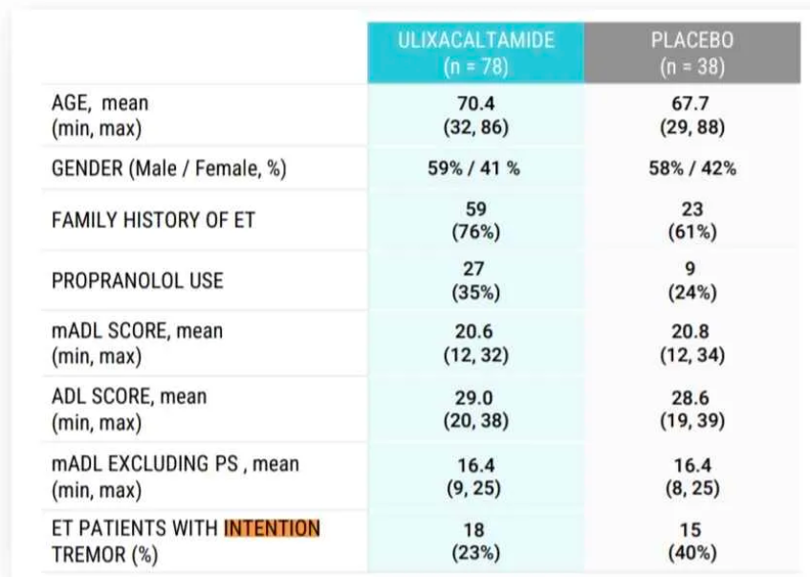
In addition, I challenge the reader to find a single Essential Tremor (ET) study that included Intention Tremor as Exclusion Criteria! There aren’t any. Propranolol, which I’ll discuss more extensively in future sections of this work, is currently the best treatment for ET, and has proven efficacious in multiple randomized, placebo-controlled, blinded clinical trials testing for its efficacy in the treatment of Essential Tremor, none of which had Intention Tremor as exclusion criteria.
T-Type Calcium Channel (TTCC) Inhibitors and their misfortune in the treatment of Essential Tremor
Multiple attempts at testing ulixacaltamide’s proposed mechanism of action for the treatment of Essential Tremor have been made.
- Jazz Pharmaceuticals’ suvecaltamide/CX-8998 failed a Phase 2b clinical trial and the company discontinued its development for ET, although data was not made available.
- Neurocrine Biosciences’ NBI-827104 also failed.
- Ethosuximide, a generic medication, also thought to be a TTCC inhibitor, was the subject of some clinical trials for the treatment of ET, but consistently failed to prove itself efficacious.
Praxis Pharmaceuticals defends the idea that none of these 3 drugs were proven TTCC inhibitors, as none of their clinical trials included endpoints for this purpose.
I find it extremely unlikely that none of them had TTCC blockage properties.

Even if these weren’t TTCC Inhibitors, it is not obvious that TTCC Inhibitors have any effects on the treatment of ET
The company seems to consider propranolol’s effect in the treatment of ET is related to TTCC blockage, which there simply is no evidence for. The mechanism by which propranolol exerts its therapeutic effect in essential tremor is incompletely understood.

Ulixacaltamide may not be a T-Type Calcium Channel Inhibitor
Ulixacaltamide has only been tested for its properties in animal studies, never in human studies. There are obvious reasons to be skeptical of the translatability between results in rat and human studies.

Assessing the Risk of Short-Selling
Since multiple uncorrelated conditions must all be correct for this drug to work as a treatment for essential tremor, I suggest estimating the probability of this being the case.
All of the following conditions need to be true in order for ulixacaltamide to work in the treatment of Essential Tremor (attributed probabilities are conservative estimates):
  - Jazz Pharmaceuticals failed to make a working TTCC inhibitor (60%)
  - Neurocrine Biosciences failed to make a working TTCC inhibitor (60%)
  - Ethosuximide doesn’t have TTCC blockage properties (90%)
  - TTCC blockage is a viable mechanism for the treatment of essential tremor (50%)
  - Ulixacaltamide is a working TTCC inhibitor (50%)
The cumulative probability is 8.1%.
Even if all of these are true, the average replication probability, for the phase 3 this trial (assuming: p=0.042, n=400, prior trial’s n=131) is only 70.06% (limited power to detect the effect noticed in Phase 2)
I deem the probability that this trial succeeds to be ~5.7%.

